|  |  |
| --- | --- |
|  | **SACRED HEART DEGREE COLLEGE, NAIPALAPUR, SITAPUR (ST-08)** |

**DEPARTMENT OF BCA**

**SESSION 2021-2022**

**Computer Laboratory and Practical Work of**

**Introduction to DBMS**

|  |  |
| --- | --- |
| Name: Sanjeev Kumar Pal | Stream : BCA |
| Roll No: 0205077 | Year : III |
|  | Semester: V |

Submitted to:- Submitted by:-

Mr.Pankaj Srivastav Sanjeev Kumar Pal

**SACRED HEART DEGREE COLLEGE, NAIPALAPUR SITAPUR**

**DEPARTMENT OF BCA**

**Session 2021-2022**

Practical Manual and Record

This is certify that Mr.Sanjeev Kumar PalRoll no **0205077** has completed the practical file and work as per syllabus of CSJM university, Kanpur in the subject Computer Laboratory and Practical Work of Introduction of DBMS and paper code **BCA-S301T**.

**Head of Department Subject Teacher**

**BCA**

**INDEX**

|  |  |  |  |
| --- | --- | --- | --- |
| **S.No.** | **Program** | **Page No.** | **Sign** |
| 1 | RDBMS definition. | 01 |  |
| 2 | About Database software which is used for Sql Programming(Oracle or MySQL).. | 02 |  |
| 3 | Creation of User and granting privilege. | 03 |  |
| 4 | Use of Char, Varchar, Varchar2, number in queries. | 04-05 |  |
| 5 | Display the structure of table. | 06 |  |
| 6 | Implementation of Create, Insert Commonds. | 07 |  |
| 7 | Create any table, insert data and display it by select query. | 08 |  |
| 8 | Create any table, insert data and display it by select query using where clause. | 09 |  |
| 9 | Alter command implementation using add and modify. | 10-11 |  |
| 10 | Alter command implementation for deletion of any column. | 12 |  |
| 11 | Implementation of drop, delete and Truncate. | 13 |  |
| 12 | Update command implementation. | 14-16 |  |
| 13 | Implementation of Equi Join. | 17 |  |
| 14 | Implementation of self join. | 18 |  |
| 15 | Implementation of Left outer Join. | 19 |  |
| 16 | Implementation of right outer join. | 20 |  |
| 17 | Implementation of Union Clause. | 21 |  |
| 18 | Implementation of Intersect Clause. | 22 |  |
| 19 | Implementation of Minus Clause. | 23 |  |
| 20 | IN and NOT IN implementation by suitable example. | 24 |  |

**Program : 01**

RDBMS definition :

**RDBMS** stands for **Relational DataBase Management Systems**. And RDBMS is used t store, manage, query and retrieve data stored in a system.

The RDBMS provide an interface between users and application. All the modern system like SQL, mySQL.IBM, Oracle are based on RDBMS.

It is most commonly used DB. It contains number of tables and each table has its own primary key.

1. Data is represented in terms if tuples.

2. Due to collection organization set of tables.

3. A row of table is called record.

4. A blank during creation is called NULL value.

Application of DBMS :

 1.In Banking

2.In Railway

3.In Airlines

4.In Education

5.In Communication etc.

**Program: 02**

About Database software which is used for Sql Programming(Oracle or MySQL).

MySQL is currently the most popular DBMS software is used for managing the relational DB. SQL is used for create, maintain and execute the Query.

SQL is stand for Structural Query language used to manipulate the data in the table.

1. It allows us to implement database operations on tables, rows, columns.
2. It defines the DB relationship in form of table.
3. It uses many SQL queries and combines useful information from multiple tables from the end users.
4. It provides the referential integrity between rows or columns of tables.

MySQL Queries :

1. Create DB

create DB ;

1. Alter Query

Alter table customers Add age varchar(50);

1. Insert Query

insert into customer values(‘101’,’Rahul’);

**Program: 03**

Creation of User and granting privilege.

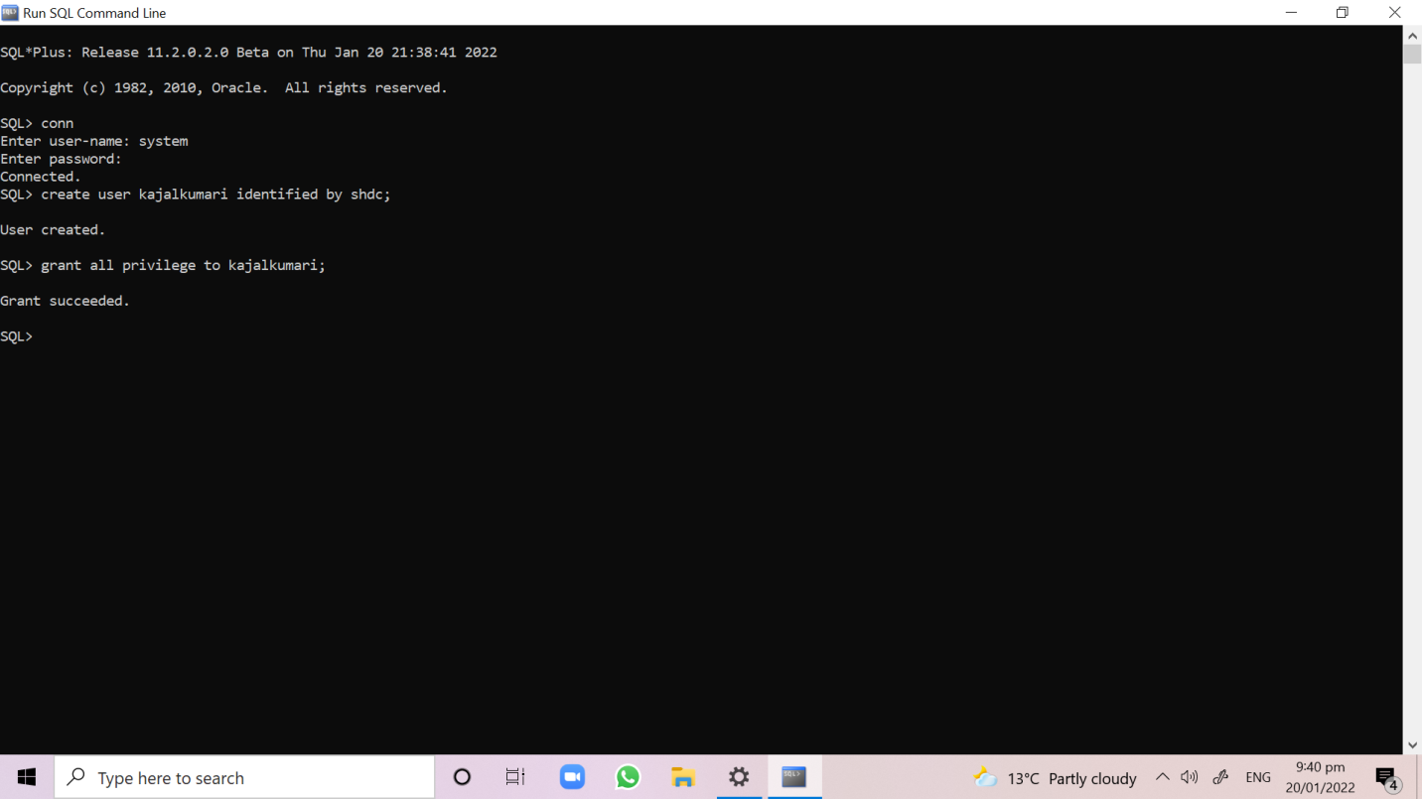

**Program: 04**

Use of Char, Varchar, Varchar2, number in queries.

Char, Varchar Queries –

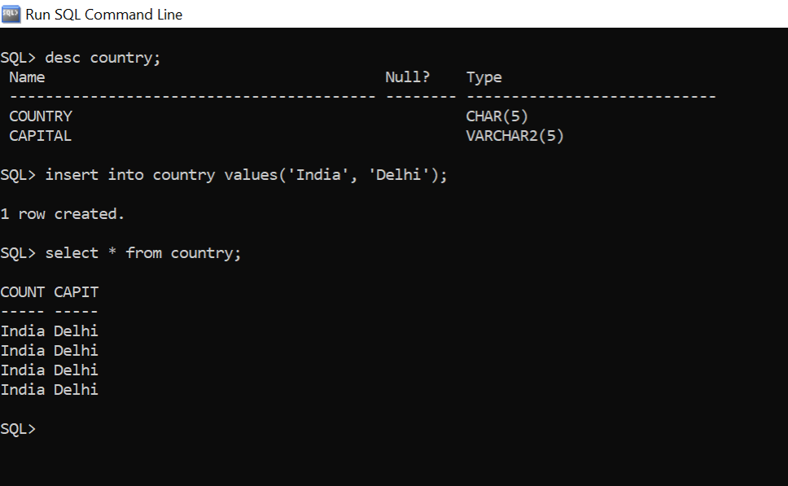

Varchar2, number Queries –

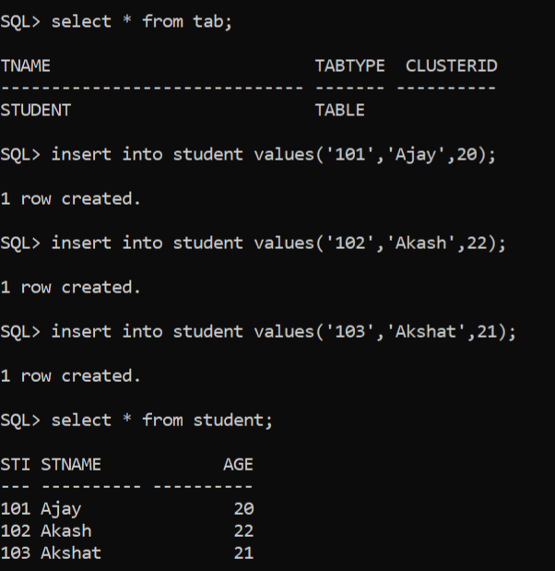

**Program: 05**

Display the structure of table.

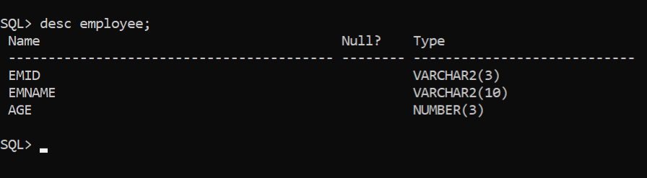

**Program: 06**

Implementation of Create, Insert Commonds.

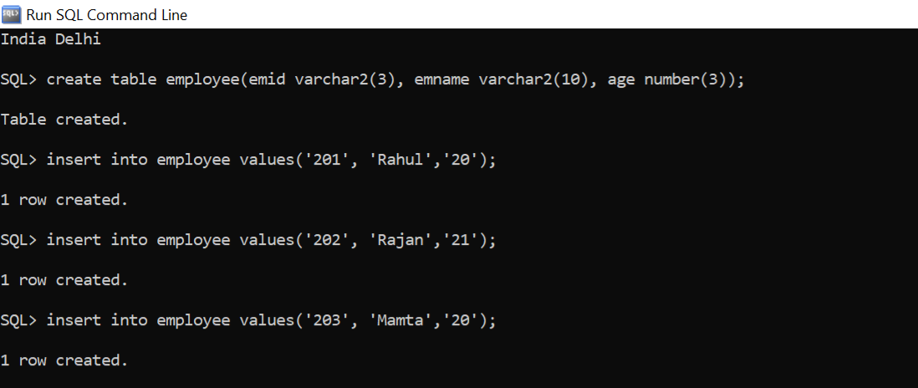

**Program- 07**

Create any table, insert data and display it by select query.

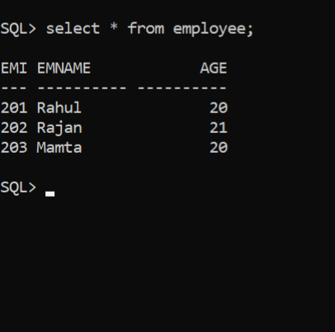

**Program: 08**

Create any table, insert data and display it by select query using where clause.

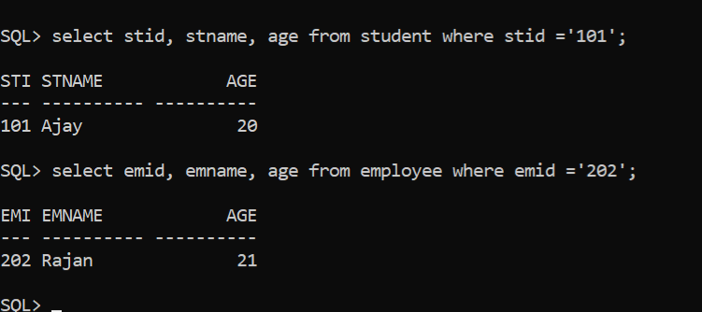

**Program: 09**

Alter command implementation using add and modify.

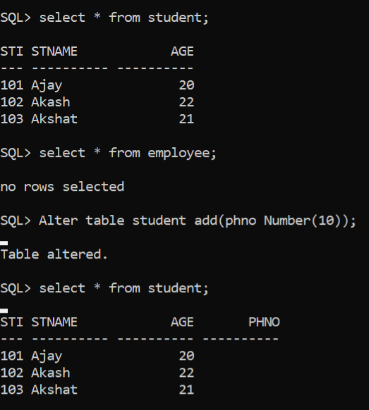

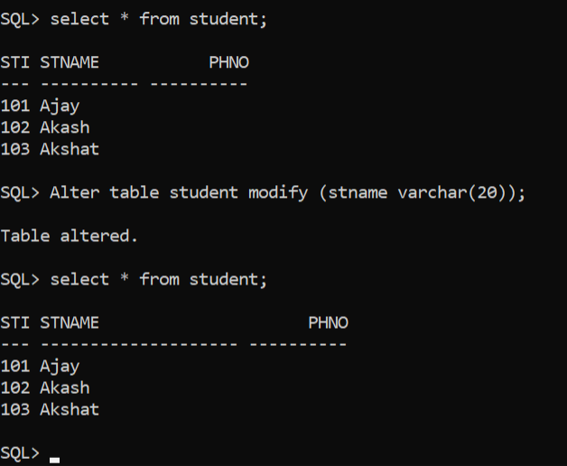

**Program: 10**

Alter command implementation for deletion of any column.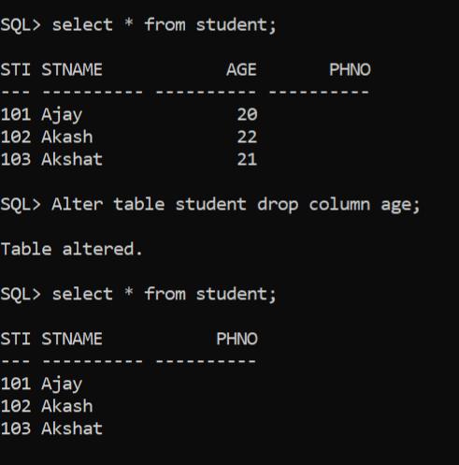

**Program: 11**

Implementation of drop, delete and Truncate.

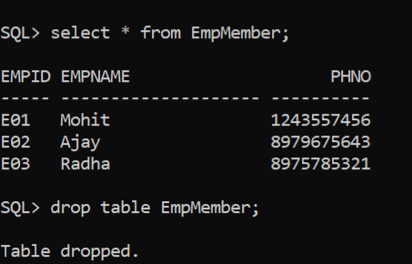

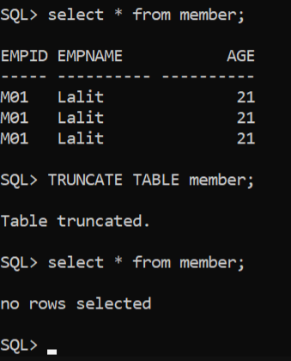

**Program: 12**

Update command implementation.

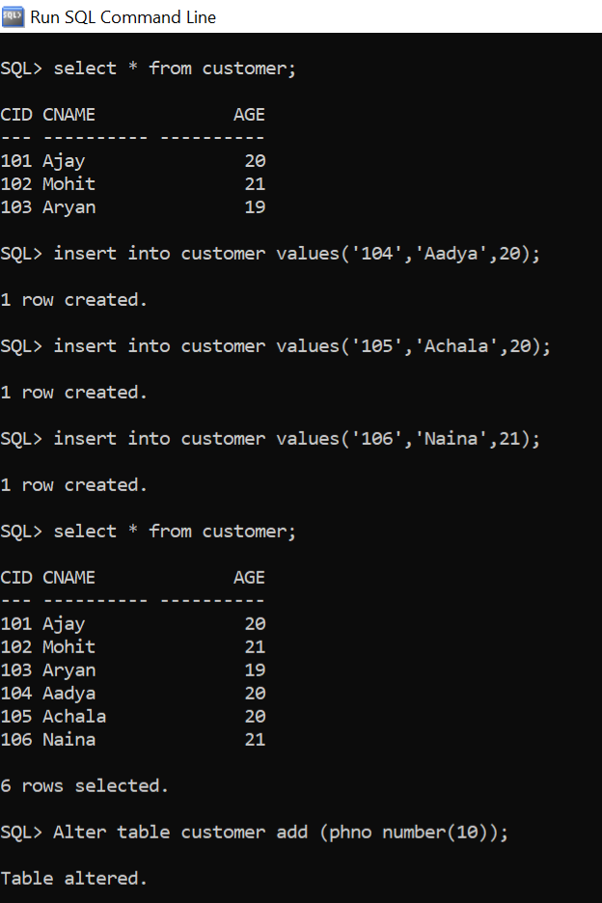

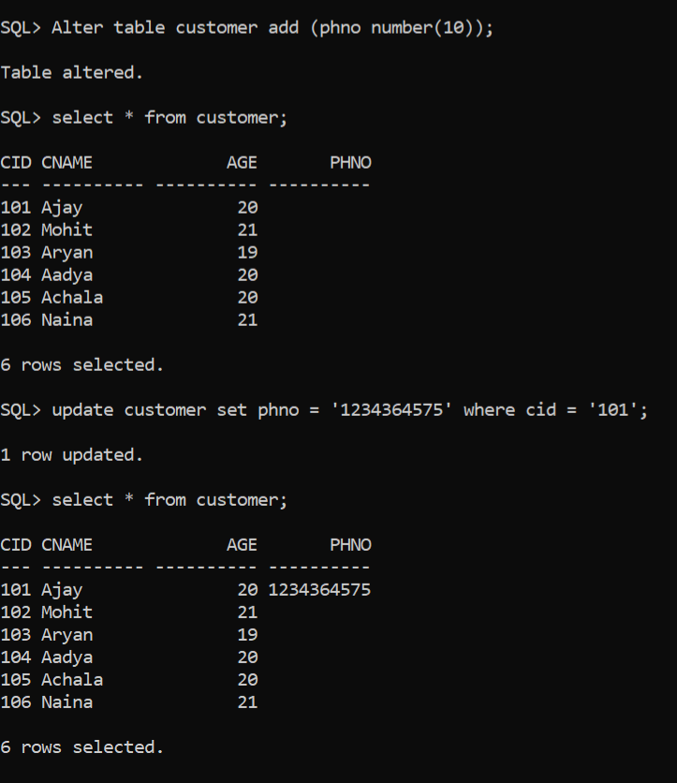

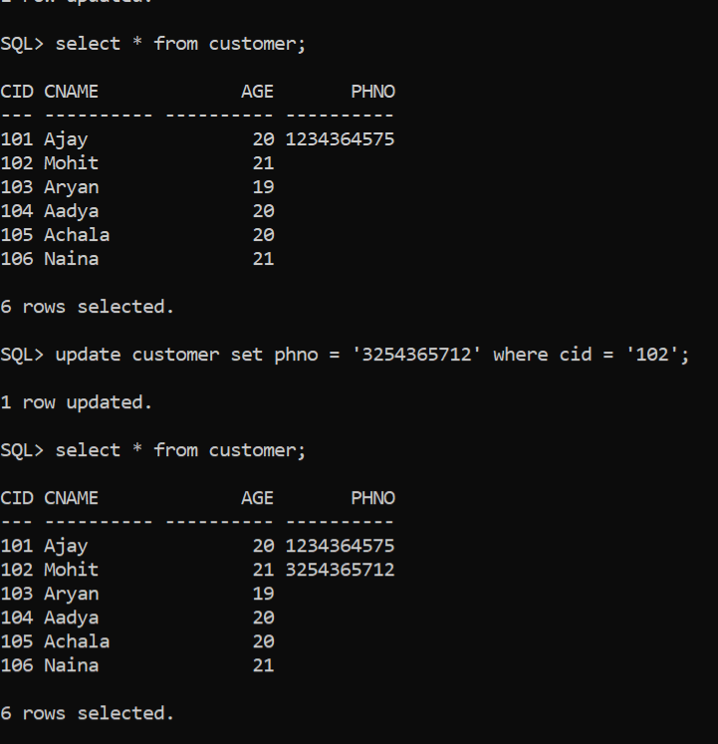

**Program: 13**

Implementation of Equi Join

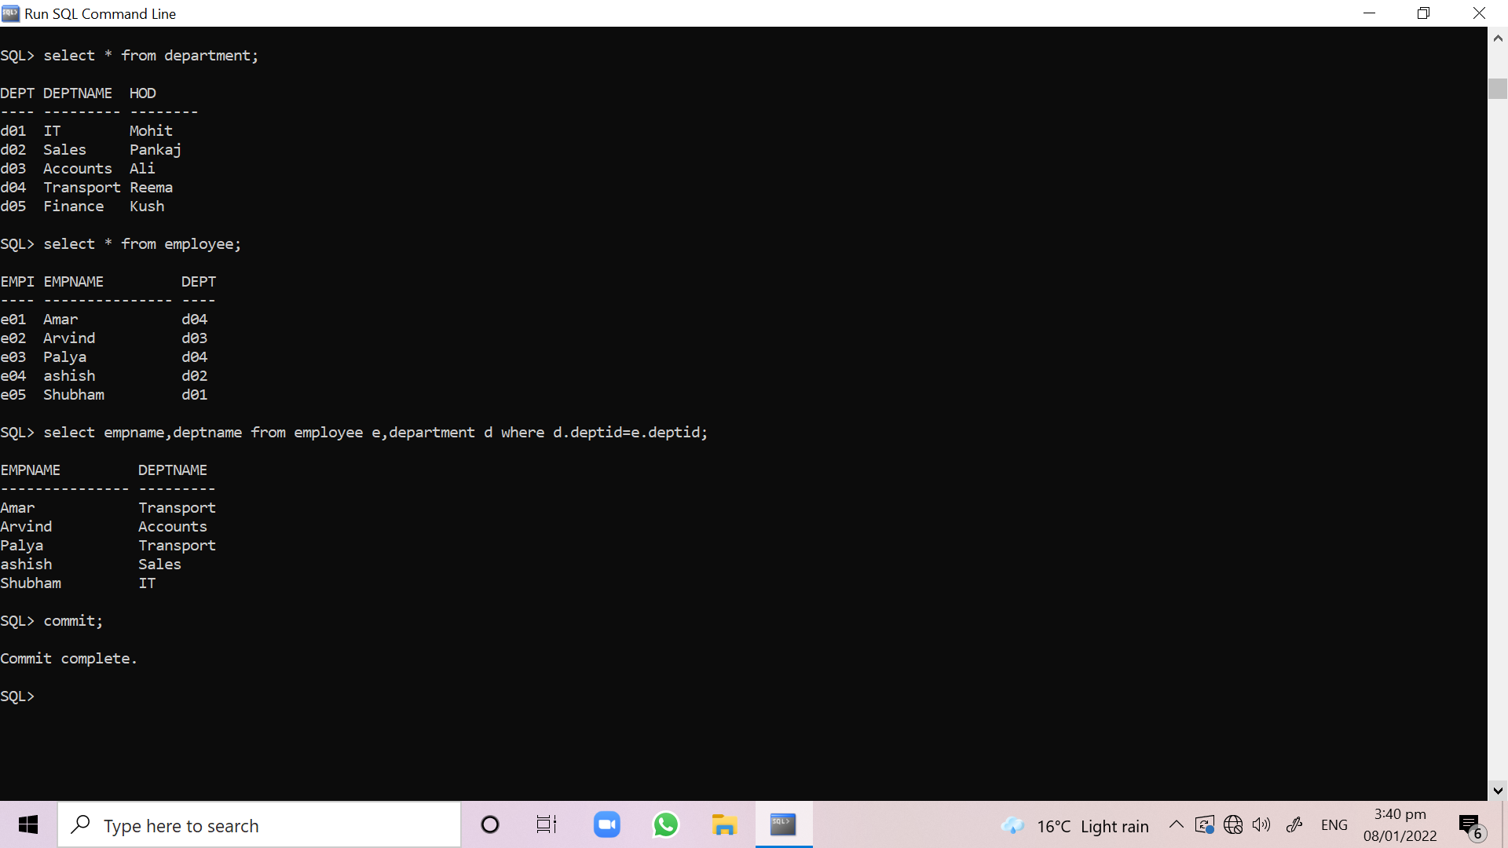

**Program: 14**

Implementation of self join

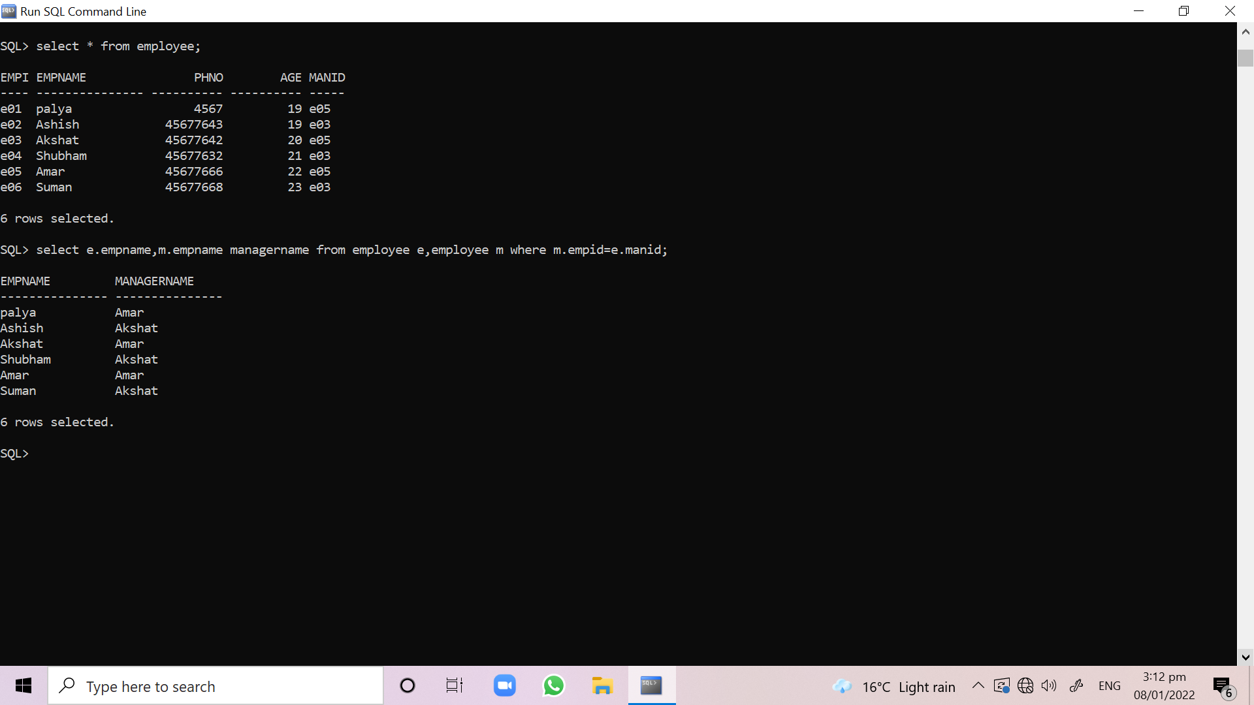

**Program: 15**

Implementation of Left outer Join

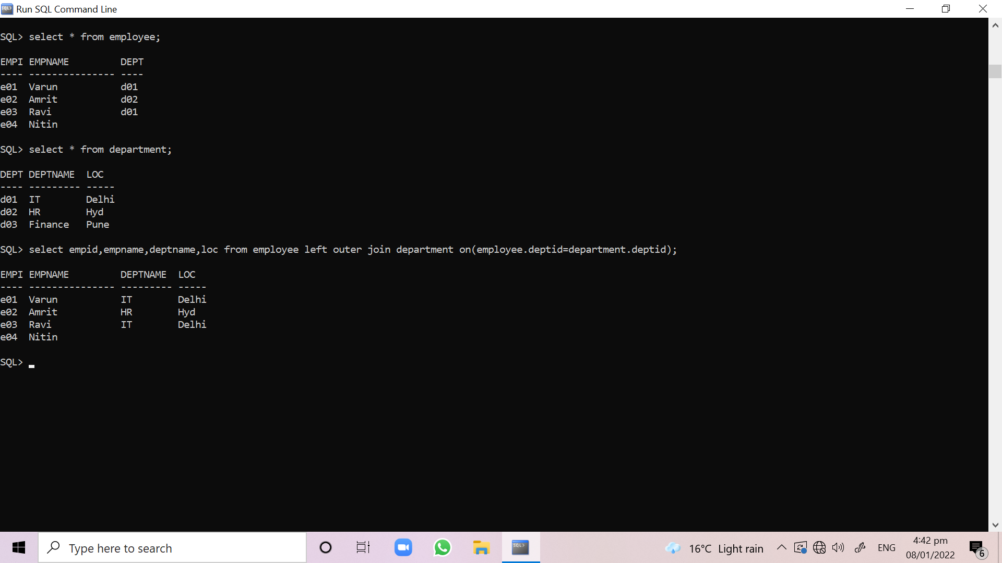

**Program: 16**

Implementation of right outer join

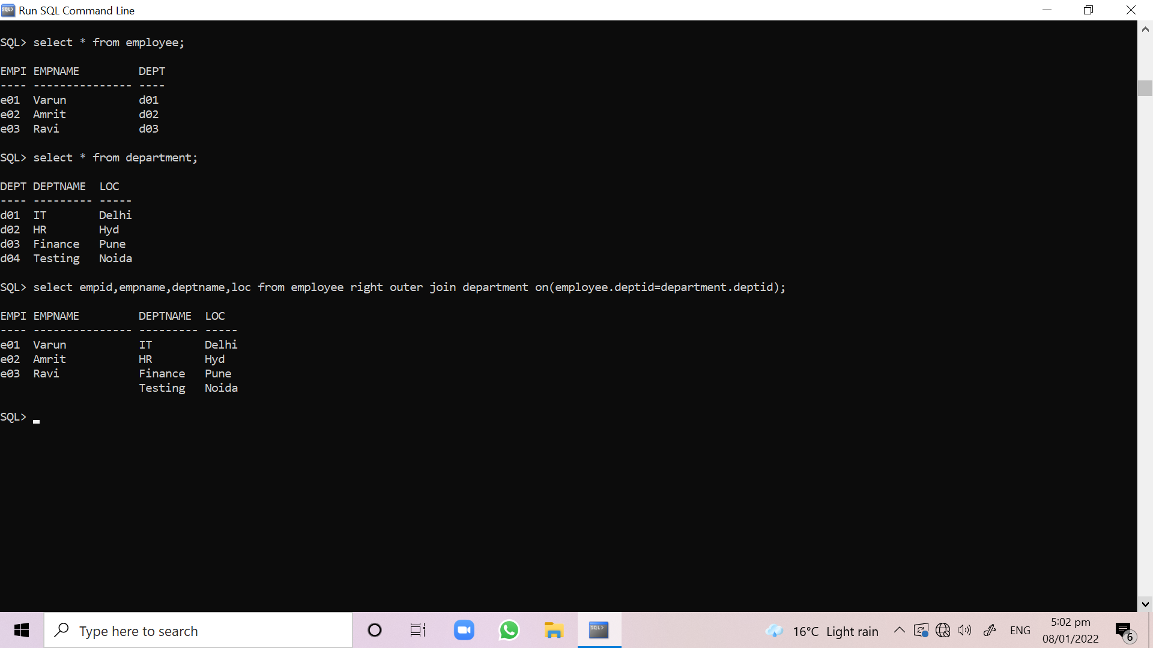

**Program: 17**

Implementation of Union Clause

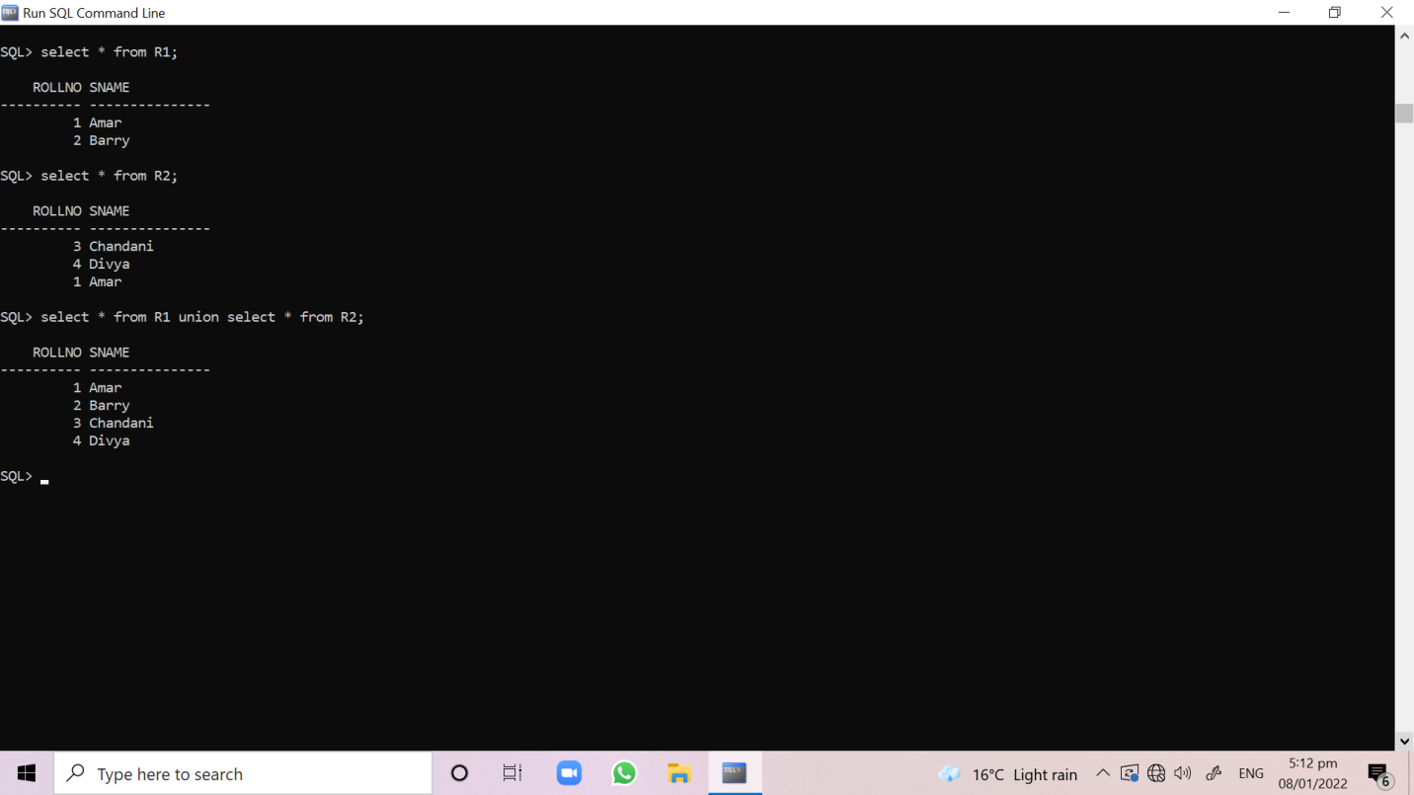

**Program: 18**

Implementation of Intersect Clause

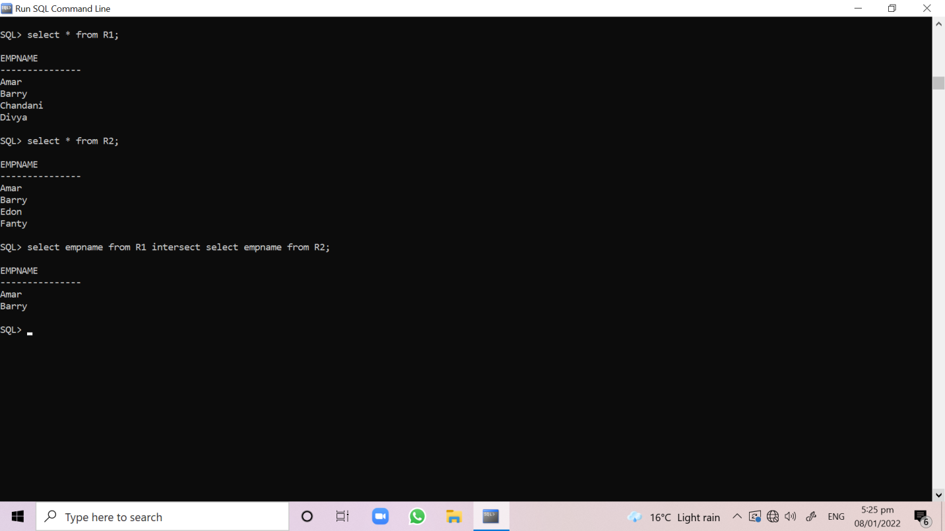

**Program: 19**

Implementation of Minus Clause

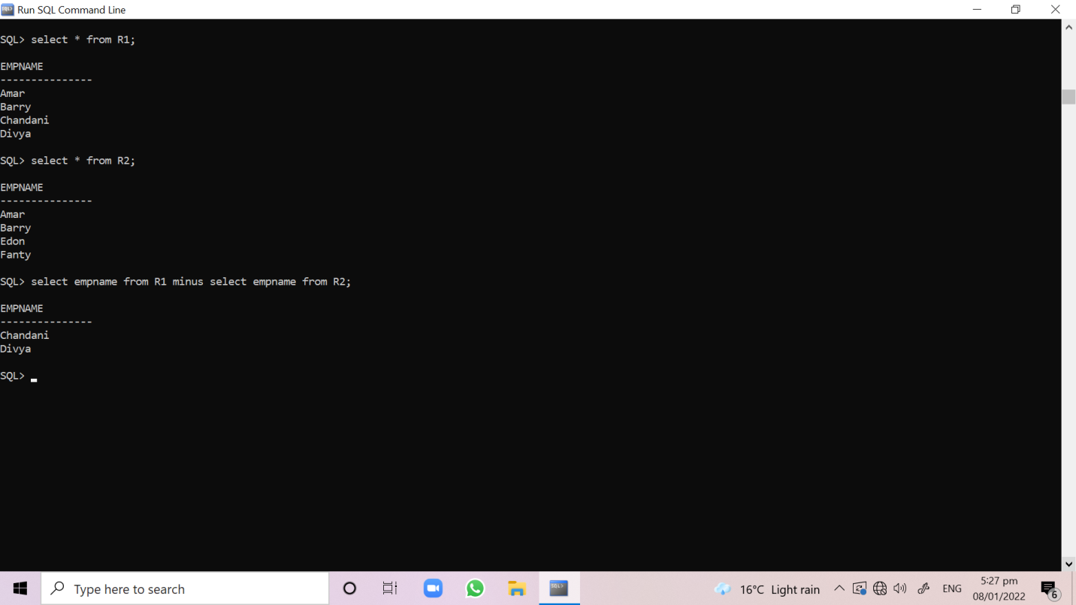

**Program: 20**

IN and NOT IN implementation by suitable example

